1. Model Persistence Techniques. (4 Marks)
a) Identify and describe three different model persistence techniques used in machine learning.
Ans:
Three model persistence techniques to save trained ML model so that it can be reused later are : pickle, joblib and ONNX

b) Explain their use cases, supported model types and common pitfalls or compatibility issues when used across environments.
Ans:
Pickle
Use case: testing on local or small models, simple small projects.
Supported model types: are python objects, dictionaries, scikit learn.
Pitfall: pkl file may pose security issues as loading pkl file from others can execute arbitrary codes. Version compatibility can pose issue as models saved in previous version cannot be opened in a newer version.
Joblib
Use case: can handle huge and complex models, from scikit learn library.
Supported model types: optimised for Scikit learn models that contain large arrays.
Pitfall: library mismatch. If you save a model with scikit-learn v1.0 and try to load it in v1.5, it will likely crash.
ONNX (Open Neural Network Exchange)
Use case: for high performance production, saves model in a universal way that any programming language can understand.
Supported model type: Deep Learning (TensorFlow, PyTorch) and Scikit-learn (via converters).
Pitfall: needs a runtime like onxruntime library to installed.

c) Compare these techniques in terms of serialisation speed, Cross-platform compatibility and Human readability.
Ans:
 | Pickle | Joblib | ONNX
Serialisation speed | med | high | low
Cross-platform | None | None | high
Human readaility | None | None | None

d) Present your findings in a comparison table and describe when to use each.
 | Pickle | Joblib | ONNX
Serialisation speed | med | high | low
Cross-platform | None | None | high
Human readaility | None | None | None
Use case | Small Python objects | Large Scikit-learn models | Production & Mobile Apps
Supported models | Python | Models with large NumPy arrays | Deep Learning & Scikit-learn

2. Model Serving with RESTful APIs. (4 Marks)
a) Explain the role of Flask + Connexion in serving models via REST APIs.
Ans:
Flask handles web requests while Connexion acts as a manager that ensures the web requests follow a strict set off rules.
Flask –
- Request Handling: It listens for incoming data (like JSON features) from users.
- Routing: It directs specific URLs (e.g., /predict) to the Python function that runs your model.
- Production Readiness: lightweight and integrates easily with production servers.
- Flexibility: It allows you to load models (using Pickle, ONNX, or TensorFlow) into memory when the server starts.
Connexion –
- Automatic Validation: It automatically checks if the incoming data matches your requirements. If the data is wrong, it returns an error before it ever touches your model.
- Automatic Routing: Don't have to write @app.route decorators. Connexion maps the endpoints in your YAML file directly to your Python functions.
- Built-in UI: It provides an interactive Swagger UI page where users can test your model in the browser without writing any code.

b) Discuss the advantages of using an OpenAPI specification in this context.
Ans:
Advantage:
- Automatic Validation: Rejects bad data before it reaches your model.
- Live Documentation: Generates an interactive Swagger UI for testing predictions in a browser.
- Single Source of Truth: Ensures code and documentation never get out of sync.
- Design-First: Lets teams agree on input/output formats before the model is even finished.
- Consistency: Standardizes error messages and data structures across different model APIs.

c) Compare REST API model serving with MLflow-based serving.
Ans:
Control: Better control and customisation using REST API and is easier to integrate .

d) Include example tools for model deployment (e.g., Flask, FastAPI, MLflow).
Ans:
Model deployment tools fall into two categories: Custom Web Frameworks (high control) and ML Orchestration Platforms (high automation).
Custom Web Frameworks : flask, fastapi, connexion.
ML Orchestration Platforms : MLFlow, BentoML, Ray serve
3. Consuming ML APIs in Full Stack Applications (6 Marks)
You are provided with a deployed machine learning API with a /predict endpoint. The endpoint expects a POST request:
a) Describe how you would consume the /predict endpoint, considering API request structure
Ans:
1. Construct the request ; include the endpoint URL, headers, authentication, request body.
2. Determine the implementation methods; client-side or server-side
3. Handling the response; asynchronous processing of API calls, success logic, error handling, parsing, logging.

b) Describe how you would consume the /predict endpoint, considering handling asynchronous responses
Ans:
- Use async/wait pauses the execution
- Try/catch blocks for timeout
- Webhooks The client provides a URL, and the ML API sends a POST request back to the client's server once the inference is complete.

c) Describe how you would consume the /predict endpoint, considering CORS and security implications
Ans:
Consuming a /predict endpoint requires securing the communication and ensuring the browser is permitted to talk to the model server.
When handing CORS , if the frontend is making an API call on a different domain, browser should block the request by default for security.

d) Implement a basic request to the API using your chosen method (JavaScript, Python, Postman, etc.). Include code and sample input/output.
Ans:
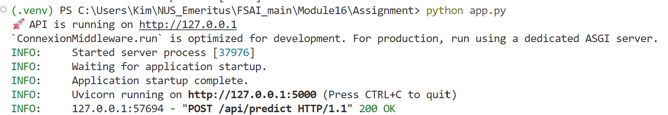

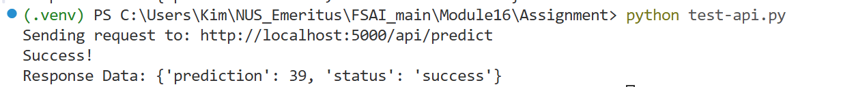

4. MLflow Model Serving (6 Marks)
a) Briefly describe what MLflow is and how it differs from custom Flask APIs.
Ans:
MLFlow is a specialized tool that automatically turns a trained machine learning model into a REST API endpoint. Less coding is required to create the api and does not need to write routes and functions like in connexion/flask method. It is automatic using the mLflow library

b) Use MLflow to serve a saved model locally or via mlflow.models.serve.
